Carrier 411 update ideas
Submitted by Candice Morrissey
Lead, Multi-Market Analyst – CO and TX
Instead of Colorado Carrier 411:
Carrier Name and Logo – State

Then eliminate the logo for each section and line item

I agree and think that this would look great (similar to our Short 411s); however, it looks like she filtered Aetna only from the Level Funded Medical Carrier 411. I wouldn’t want this as a default feature. Couldn’t this be done as an editable PDF?
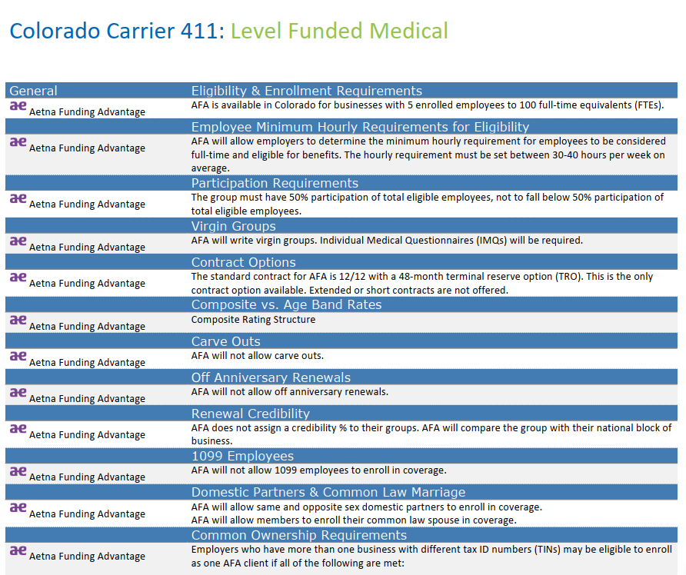
When saving as spreadsheet split the information up in designated columns such as: I am not aware of the ability to save as a spreadsheet?
General | Topic | Description
 | Eligibility & Enrollment Requirements | FA is available in Colorado for businesses with 5 enrolled employees to 100 full-time equivalents (FTEs)

This will allow us to create a merge document based on Topics selected and Description. Merge documents could be a one-page flyer with different carriers (example Carrier Matrix)
Review of all questions and format for LF CO and TX
Fix the character issue where we can copy directly from either a Word or Excel document directly to the Admin 411 – due to this flaw, we currently have to copy from Word or Excel, onto WordPad and then copy from WordPad to paste into the Admin 411. Fixing the character issue would illuminate one step.
Agreed – this would be a huge timesaver! The individual would still need to check for typos, etc. when copying/pasting.
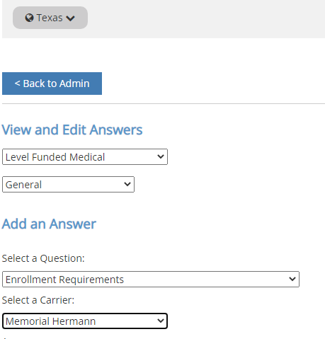
Currently when you go back to check your responses in Admin 411, you select Select a Carrier and it shows every carrier that is in there. (sample of issue below)
Update functionality so that when you select a carrier it only brings that carrier up to review and make edits.
On that note; would it be possible to bring up all the questions instead of having to go through each category/section to review and edit for that one carrier?
This would be a nice feature when adding a new carrier.

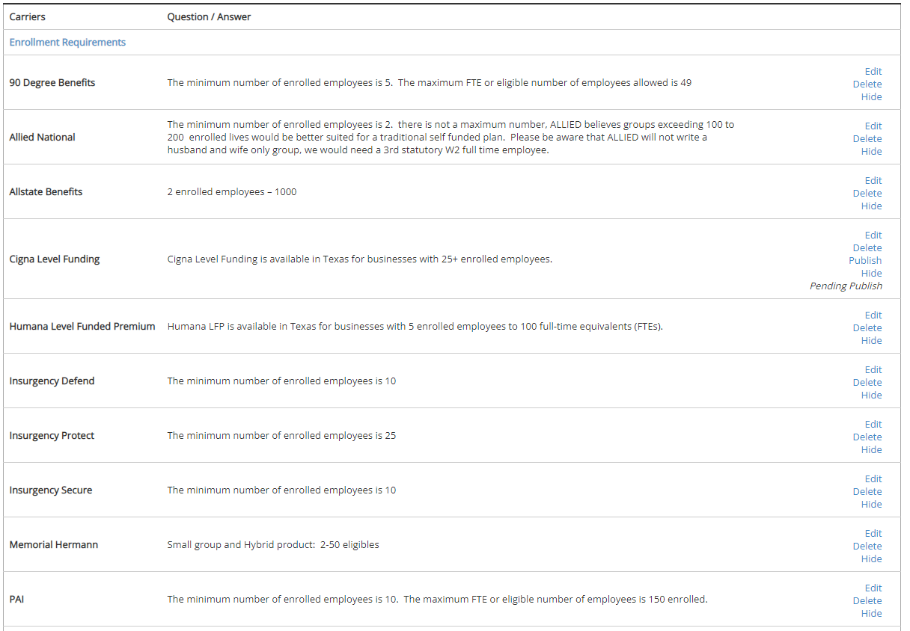
Export a list of all questions to minimize duplicates in different areas We currently have the ability to download all questions from a 411.
Can the program recognize when a duplicate response has been published? Working in this program, and with other things going on, you can publish a response more than once. Yes, this can happen. I would suggest slowing down and double checking once answers are published.

